Walker River Decision Support Tool (version 2.0):

User Guide

Douglas P. Boyle, University of Nevada, Reno

Chris Garner, University of Nevada, Reno

Enrique Triana, MWH Global

Table of Contents

1. Overview 5

2. Contents of the DVD 5

3. Additional Software Requirements (Not on the DVD) 5

4. System Requirements 5

Supported Operating Systems 5

Hardware Minimum Requirements 5

System Settings 5

Runtime Requirements 6

5. Installation and Setup of DST 6

DST Workspace Setup 6

Installing Microsoft .Net Framework 4.0 6

Installing the Walker DST Controller 6

Installing MODSIM-DSS 8.1 for Windows 7 8

Installing MODSIM-DSS 8.1 for Windows XP 8

To obtain the MODSIM-DSS 8.1 user manual, for Windows 7 and XP, open the following link: 8

MODFLOW 9

Microsoft Access 2010, Microsoft Visual Studio 2010, & ArcGIS 9.3 9

MODFLOW post-processing software 9

6. DST Files Workspace Reference 9

Data Files 9

GIS Files 10

DST Files 12

MODSIM Files 13

MODFLOW Files 13

7. DST User Guide 13

Overview 14

DST Preferences 16

MODSIM Network Preparation 16

Surface Water Allocation Module 19

HRU Water Balance Module 20

Groundwater Modeling Module 21

Convergence Checks 22

8. Run the Baseline and Application 80700 23

Setting the Workspace 24

Performing the Baseline Run 24

Performing the Application 80700 Run 26

9. Viewing and Comparing the Results 27

MODSIM 27

HRU Water Balance 27

MODFLOW 29

10. References 31

List of Figures

Figure 1. Walker DST Controller GUI 14

Figure 1. Walker Basin DST Modeling System Components Diagram 15

Figure 2. Walker DST Preferences User Interface 16

Figure 3. Walker DST Water Rights Scenarios User Interface 18

Figure 4. Walker DST Surface Water Allocation Module User Interface 19

Figure 5. Walker DST HRU Water Balance Module User Interface 21

Figure 6. Walker DST Groundwater Module User Interface 22

Figure 7. MS-Access Default Database Folder Options 28

List of Tables

Table 1. DST Workspace 9

Table 2. Data File Inventory 10

Table 3. GIS File Inventory 10

Table 4. Scenario Management Databases 12

Table 5. Scenario-Based Databases in the DST Folder 12

Table 6. DST Modules and Operations 14

Table 7. MODSIM Network Preparation Steps 17

Table 9. Additional MODSIM Network Preparation Steps 18

Table 10. MODSIM Network Preparation Steps (During Iteration Process) 19

Table 11. Water Balance Execution Summary 20

Table 12. Run Summary Table 22

Table 13. Listing of available information in WG_Summary_HRU queries 29

## Overview

This document is intended to be a user guide to the installation and operation of the Walker Basin Decision Support Tool (DST) (version 2.0). It provides a basic knowledge of the modeling system and allows the user to repeat the Baseline and Application 80700 DST runs as described in the report *Walker River Decision Support Tool (version 2.0): Application and Analysis of NSE Application 80700 (Boyle et al. 2013)*.

## Contents of the DVD

The DVD that accompanies this report contains the following:

* This Document (Walker_DST_Phase2.0_UserGuide.docx)
* Walker Basin DST Compiled Software (DSTSetup.msi)
* *WalkerFiles* Modeling Workspace (MODFLOW Executables Included)
* Microsoft .NET Framework (4.0 and 1.0)
* Walker Basin DST Visual Basic Source Code and Visual Studio 2010 Solution Directory
* MODSIM-DSS 8.1 (For Windows 7 and Xp)

## Additional Software Requirements (Not on the DVD)

* Microsoft Access for Windows 2010 is required to view tables and queries created by the DST.
* ArcGIS 9.3 is required to visualize the GIS data used by the DST.
* MODFLOW post-processing software (Examples: Groundwater Vistas or GMS) is required to view and analyze the MODFLOW output.
* Microsoft Visual Studio 2010 is required for debugging of the Walker DST source code.

## System Requirements

The Walker DST requires a minimum system configuration with the following characteristics:

### Supported Operating Systems

* Windows 7 Ultimate, Enterprise, Professional, Home Premium (32-bit and 64-bit (EM64T)) – SP1
* Windows XP Professional (32-bit) – SP3

### Hardware Minimum Requirements

* CPU Speed: 2.2 GHz minimum or higher; Hyper-threading (HHT) or Multi-core (2 core minimum) Processor
* Intel Pentium 4, Intel Core Duo, or Xeon Processors
* Memory/RAM 4 GB or higher
* Disk Space 100 MB (application) and 10GB for DST execution

### System Settings

* The user must have administrator rights on the system in order to install the software components.

### Runtime Requirements

* MS Access and (or) ArcGIS must not be running simultaneously with the DST software.
* User must not access the system remotely

## Installation and Setup of DST

### DST Workspace Setup

Copy and paste the *WalkerFiles* workspace folder to any hard drive location where sufficient free disk space (as defined in the system requirements section) is available. Make note of this location because it will be used to set the DST Preferences a later point in the guide.

### Installing Microsoft .Net Framework 4.0

Microsoft .NET Framework is located on the DVD in the *DotNetFramework* folder. Double click on *dotNetFx40_Full_setup.exe* to begin the installation of .Net Framework 4.0. Please accept all installation defaults.

### Installing the Walker DST Controller

A compiled version of the DST is provided in an install file referenced in the contents of the DVD section (DSTSetup.msi). The install file is located in the *DST_CompiledSoftware* folder.

Double click on the setup file to begin the installation. If you’ve failed to install the proper .NET framework version you will be prompted to download the appropriate version. Please be sure to install the version referenced above (i.e. do not download the required file from the internet).

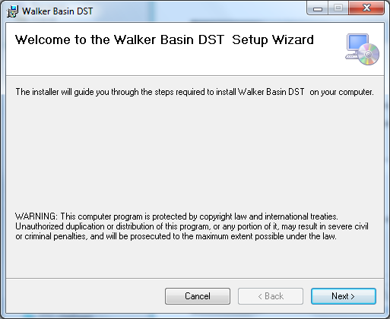

The default install location will be C:\Program Files (x86)\UNR\Walker Basin DST\. Please accept the default location, choose “Just Me” and click next. Click next to start the installation and then click close after installation is complete.

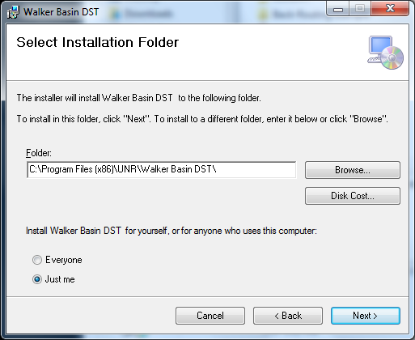

Confirm the installation by clicking next.

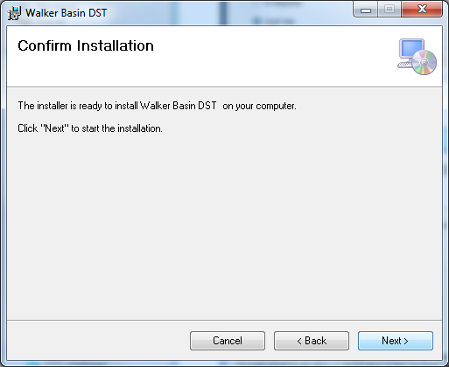

Click Close to finish the DST Controller installation.

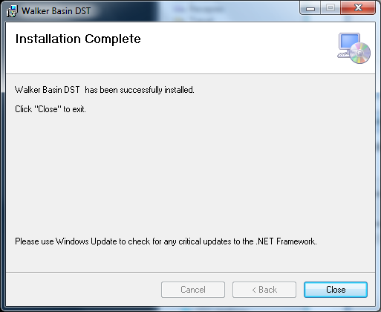

### Installing MODSIM-DSS 8.1 for Windows 7

The MODSIM-DSS 8.1 software is located in *MODSIM8.1.zip* on the accompanying DVD. Extract the contents of the *MODSIM8.1.zip* to C:\Program Files(x86)\MODSIM8.1.

There isn’t a setup file for the Windows 7 version of MODSIM 8.1, so the system needs to be told that MODSIM8.1 will open files with the extension “.xy”. Double click on “WalkerNet.xy” in WalkerFiles\MODSIM\Baseline\. You should receive a “Windows cannot open this file:” dialogue. Choose select the program from a list. Make sure “Always use the selected program to open this kind of file” is checked and browse to C:\Program Files(x86)\MODSIM8.1\, and select ModsimGUIver8.exe. This will associate all .xy files on the system with MODSIM8.1.

### Installing MODSIM-DSS 8.1 for Windows XP

The MODSIM-DSS 8.1 software is located in *MODSIM/WindowsXP/MODSIM8.1Setup.msi* on the accompanying DVD. Double Click on *MODSIM8.1Setup.msi* and accept all default installation settings*.*

##### Installing Microsoft .Net Framework 1.1 (Windows XP Only)

MODSIM for Windows XP requires Microsoft .NET Framework 1.1. The file is located on the DVD in the *DotNetFramework* folder. Double click on *dotnetfx.exe* install file to begin the installation of .Net Framework 1.1. Please accept all default installation settings.

### To obtain the MODSIM-DSS 8.1 user manual, for Windows 7 and XP, open the following link:

<http://modsim.engr.colostate.edu/version8.shtml>

Locate “Click **HERE** to download **MODSIM 8.1** documentation, examples, …” and click on **HERE** to access the documents on the BytesFall Explorer. Follow the instructions listed on the aforementioned web page to download the user manual. A tutorial and example applications are also available for download.

### MODFLOW

The MODFLOW executable for each model is included in the *WalkerFiles* DST workspace in its respective basin (Mason and Smith) so there is nothing to install; the executable will be called from the DST controller. Please see the *Online Guide to MODFLOW-2000*:

<http://water.usgs.gov/nrp/gwsoftware/modflow2000/Guide/index.html>

for additional information. The specific version used in both of the MODFLOW models is USGS Ground-Water Software MODFLOW-2000 Version 1.19.01.

### Microsoft Access 2010, Microsoft Visual Studio 2010, & ArcGIS 9.3

Please follow the manufacturers guidelines for installing these software packages.

### MODFLOW post-processing software

MODFLOW post processing software is available from Groundwater Vistas and GMS. Please follow the manufacturers guidelines for installing these software packages.

## DST Files Workspace Reference

The DST workspace refers to the structure of folders in which the files are organized and provided to the user. The workspace is useful to pack and transport the large number of files used in the Walker River Basin DST, while maintaining a structure of relative paths to be used in processing, display, and summary tools. The DST workspace main folder, called *WalkerFiles,* contains 5 folders where different types of information that the tool uses are stored (Table 1).

Table 1. DST Workspace

|  |  |  |
| --- | --- | --- |
| Folder | Purpose | Organized by Scenario |
| Data | This folder contains base data for the Walker DST. It includes time series and data that is not geo-referenced |  |
| GIS | This folder contains two Geo-Databases; One with the Walker DST geo-referenced data and another with the MODSIM geometric network, |  |
| DST | This folder contains the *ScenarioInfo* database, which houses general information about the simulations and aids in a scenario management.  Also contains folders for individual scenarios with GIS data and Water Balance module results. | ♦ |
| MODSIM | Folders for scenarios with MODSIM model files | ♦ |
| MODFLOW | Folders for scenarios with MODFLOW model files | ♦ |

### Data Files

Table 2 shows the sole data file that the DST uses to setup historical surface water demands, Hydrologic Response Unit (HRU) water requirements, decree water rights, and establish reservoir geometry for calculating evaporation.

Table 2. Data File Inventory

|  |  |  |
| --- | --- | --- |
| File Name | Table Name | Description |
| Walker_ObservedData.mdb | TIMESERIES | Historical decree, flood, and storage diversions |
| NewNIWR_Master | Net Irrigation Water Requirement (NIWR) data for each basin, crop, and month |
| WaterRightsTable | Water rights table aggregated by ditch |
| WalkerACE | Reservoir Area-Capacity-Elevation Curves |

### GIS Files

This GIS folder contains all the GIS files that support the DST Modeling System. There are two files located in the GIS folder of the DST workspace (modsim_w.mdb and WalkerDST_GeoDatabase.mdb). Table 3 shows an inventory of each GIS file. ‘modsim_w.mdb’ is an ArcGIS geometric network, which is used to build the MODSIM base network (See MODSIM Files section). It contains all the essential surface system features and the connectivity of the different elements of the network. ‘WalkerDST_GeoDatabase.mdb’ contains a variety of features and tables used to compute the HRU Water Balance and translate the results to MODSIM and MODFLOW.

Table 3. GIS File Inventory

|  |  |  |
| --- | --- | --- |
| File Name | Feature/Table Name | Description |
| modsim_w.mdb | modsim_canals | Polyline feature of the Walker Basin ditches |
| modsim_demands | Point feature of the Walker Basin demands. Contains HRU Water Balance parameters. |
| modsim_gauges | Point feature of the Walker Basin gauges |
| Modsim_Network_Net_Junctions | Point feature which connects the canals and streams |
| modsim_nonstorage | Not used |
| modsim_reservoirnodes | Point feature of the Walker Basin reservoirs |
| modsim_sinks | Point feature used to collect unused supply |
| modsim_streams | Polyline feature of the Walker Basin river and drains. Contains the relationship between MOD_Name and SFR segment number. |
| WalkerDST_GeoDatabase.mdb  WalkerDST_GeoDatabase.mdb  WalkerDST_GeoDatabase.mdb | App80700_Area | The DST representation of the lands to be fallowed in the change application scenario. |
| MASMF_U_SMF_U_HRU_SubPolys | SubPolys: smaller units for Water Balance computations. Attributes from MODFLOW grid and MODSIM allow linking input and output from the HRU Water Balance |
| MASMF_U_SMF_U_HRU_SubPolys_Cent | SubPolys_Centroids: Used to programmatically find overlapping SubPolys. |
| mason_gwgd_wRC | Mason Valley MODFLOW modeling grid |
| MF_MS_FastReturnsTS_App80700 | A table of time series output of the runoff calculated by the HRU Water Balance for each HRU and month in the scenario (80700) run. |
| MF_MS_FastReturnsTS_Baseline | A table of time series output of the runoff calculated by the HRU Water Balance for each HRU and month in the baseline run. |
| MF_SFR_DiversionInflowTS | A table of time series data containing boundary condition streamflow and diversions organized by column number. Column number relates each element to its position in the MODFLOW SFR network. |
| MF_SFR_FastRetColInfo | A table containing the relationship of each HRU and the column number for runoff. Column number is a column reference for an intermediate array that relates to the flow position in the MODFLOW SFR network. |
| MF_SFR_MS_FastRetLocsFracs | A table containing each HRU, fraction(s) indicating what portion of the runoff goes to a particular location, and MOD_Name nodes for locating runoff in the MODSIM and MODFLOW stream networks. |
| MF_SFR_RoutingInfo | A table containing the location of each inflow or diversion in the SFR network. |
| MF_MS_FastReturnsTS_Baseline | A table of time series output of the runoff calculated by the HRU Water Balance for each HRU and month in the baseline run. |
| MF_WEL_DitchLeakage | A table containing Basin, HRU, MF Layer, Row, Column and a fraction of the ditch that lies above each cell. |
| MF_WEL_MountainBlockRecharge | Static table containing the Basin, MF Layer, Row, Column and an amount of Mountain Block Recharge. |
| NIWR_Tbl | A copy of the NIWR table from the Walker_ObservedData.mdb |
| NIWRAVG_Tbl | Computed average NIWR per HRU, based on the individual crops NIWR for the HRU fields. |
| pod_data | Data and information associated with each groundwater well (Not Used). |
| pod2gridSpatialJoin2 | Relationship between MODFLOW grid Row/Col to the groundwater wells (walker_pod) |
| smith_gwgd_wRC | Smith Valley MODFLOW modeling grid |
| TBM_hru_081912_CBG_Union | HRUs used to generate the subpolys |
| walker_permit | This relational table represents the permits associated with each pumping site ID. |
| walker_pod | Point feature representing pumping locations |
| walker_pou | Polygons representing the Walker Basin supplemental pumping places of use |

### DST Files

The DST folder contains files used in the management and analysis of scenarios. Table 4 contains the description of the main databases used by the DST to manage scenarios and compare results.

Table 4. Scenario Management Databases

|  |  |  |  |
| --- | --- | --- | --- |
| File Name | Feature Name (Table) | Description | |
| ScenarioAnalysis.mdb | Various | | This database contains queries and tables generated for summary and comparison of the different components of the Walker DST. |
| ScenarioInfo.mdb | Scenarios | | General information for the scenarios available in the Walker DST. |
| ScenariosINFO | | Scenario run information, including the convergence, performance metrics and file locations for each run, including the intermediate runs in the iterative process. |

The DST folder of the workspace contains subfolders for the different scenarios where processed GIS and HRU Water Balance results are stored for each scenario. These scenario-based files allow reproducing the exact data and parameters used in each scenario simulation. In each scenario folder, two databases are generated at run time:

Table 5. Scenario-Based Databases in the DST Folder

|  |  |  |
| --- | --- | --- |
| File Name | Feature Name (Table) | Description |
| GISDB_Debug.mdb | 0100_MASMF_U_SME_U_HRU_SubPolys | This table contains the scenario processed HRU SubPolys. These are the active sub-Polys (exclude the purchased) and handles for overlapping SubPolys by adjusting the area accordingly for accurate computation of the volumetric HRU Water Balance. |
| *modsim_demands* | This table includes the scenario-based coefficients, including: ditch leakage, farm efficiency and farm runoff factor for each of the HRUs. |
| WaterBalance_Debug.mdb | *BaseNet_ScenarioNameRunID_RunType* | These runtime tables contain the HRU grouped results for each run. A set of queries is created to use the Scenario GIS information and combine it with the HRU group Water Balance to generate volumetric summaries of the computed Water Balance. |
| *BaseNet_ScenarioNameRunID_RunType*_TotPumpPerWell | These runtime tables contain the total pumping per well per time step computed in the HRU Water Balance routine |

### MODSIM Files

MODSIM models and output files for the Walker DST are contained in the workspace folder *MODSIM.* This folder contains subfolders for each of the scenarios that have been run with the Walker DST. Each of the scenario folders contains all the MODSIM networks for each DST run up to convergence of that scenario.

All of the DST model runs begin from one common base network (“WalkerNet.xy”), which is located in the .\MODSIM\Baseline\ folder of the workspace. For each run of the DST, the controller module begins with the base network and incorporates data, information, and results from other modules to build a new MODSIM model for the current scenario and Run ID.

For example, a run with scenario name Baseline and Run ID 777 will have the filename, “WalkerNet_Baseline777_CAL.xy”. Alternatively, a run with scenario name App80700 and Run ID 390 will receive a file name of “WalkerNet_App80700390_SIM.xy”. Runs that are setup as calibration have CAL in the filename whereas simulation runs have SIM in the file name. The output for each MODSIM model is housed in an Access database with a name corresponding to the .xy file (i.e. WalkerNet_Baseline777_CALOUTPUT.mdb).

### MODFLOW Files

MODFLOW files for the Walker DST are contained in the workspace folder *MODFLOW.* This folder contains subfolders for each of the scenarios available in the Walker DST. Each of the scenarios sub-folders contains two folders with the mason and smith MODFLOW model files. The MODFLOW models are executed in these mason/smith folders; therefore the most current inputs and output files are found, for each scenario, in this folder. The Walker DST does not store the MODFLOW output files for each iteration, instead it saves the input files that are changed each iteration into a ZIP compress files with the corresponding Scenario and RunID. For example, the file *../MODFLOW/App80700/mason/App80700_841.zip* contains the key input files to reproduce run 841 for the scenario named App80700 in the mason valley MODFLOW model.

#### MODFLOW Base Files

The MODFLOW Base files are the essential files required for new scenario MODFLOW runs. They are stored in a folder called *BaseFiles* in the MODFLOW folder of the DST workspace and are used by the controller to create the MODFLOW workspace for new scenarios. The Base Files contain a set of required input files and the MODFLOW executable. No output files are included in the Base Files. The Base Files include separate folders for mason and smith models.

## DST User Guide

The description and user options of the different modules in the DST Modeling System are described in this section, including input files and output files, and the basic functionality of the user interfaces. The modules user interfaces are displayed at runtime at the beginning of the iteration process. The execution of the iteration process for the Baseline and Scenario are described in Section 8.

### Overview

The DST is composed of three main modules that handle the primary operations for the DST: Surface water allocation, HRU water balance and groundwater modeling. The ***controller module*** is the main user interface, displayed with the DST is started, that allows access to the DST modules and controls the simulation process and scenario management. The Controller Module provides a graphical user interface (GUI) where the DST user can create new scenarios and execute the DST models. Figure 1 shows the controller interface with the main areas identified with a number.



Figure 1. Walker DST Controller GUI

The functionality of the controller areas (shown in Figure 1) is described in Table 6.

Table 6. DST Modules and Operations

|  |  |  |
| --- | --- | --- |
| Área Number | Function | Description |
| 1 | Scenario Selection | Displays the current scenario name.  Allows creating a new scenario |
| 2 | DST General Messages | These windows show the messages generated by the DST during the execution. It includes messages for preprocessing data and executions, as well as the iteration and convergence processes. |
| 3 | Iteration Steps | These sets of grouped steps allow control of the steps performed during the DST iteration process. **The default and recommended operation is with all the steps selected.** |
| 4 | Convergence Settings | This tab controls provides options for   * Selection of single/batch iteration modes * User defined convergence criteria * (*Statistics* Tab) Convergence Table that summarizes the iteration runs for the selected scenario |
| 5 | Model Output | This area displays the standard MODSIM model run-time messages during the iteration process |
| 6 | DST Workspace | The window form title displays the active DST workspace. |
| 7 | Execution Controls | Reset Index or Execute a run |

The Controller Module provides the functionality to perform the DST iteration process where the Surface Water Module, the HRU Water Balance and the Groundwater Module interact to converge to a solution, in which all modules inflows and outflows are synchronized. The flow of information between the modules in an iteration process is illustrated in Figure 1. The iteration is identified with a unique ID, or *RunID*, that starts with a MODSIM run and ends with a MODFLOW run. Note that information for MODSIM input files from the HRU Water Balance and MODFLOW are obtained from the previous iteration (red arrows in Figure 1.)

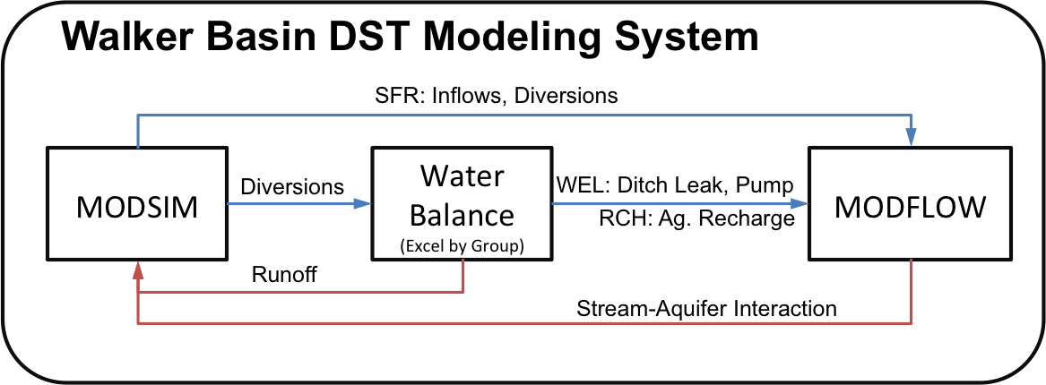

Figure 2. Walker Basin DST Modeling System Components Diagram

### DST Preferences

The DST preferences allow the user to select the DST workspace and manage the files for the different modules. The Preference user interface (UI) displays the relative paths and names of the files used by the different models and processes. The Preferences UI allows the user to edit file names and general DST options. Figure 3 shows the DST Preferences user interface including the general options, the MODSIM options, the MODFLOW options and the HRU Water Balance options.



Figure 3. Walker DST Preferences User Interface

Area 1 in the Preferences UI allows the user to type the workspace folder and browse to the workspace folder using the *Browse* button. Area 2 shows the different items managed in the DST preferences. For items that contain a file name, Area 3 can be used to update the DST preferences. For example in Figure 3, the MODSIM network is selected from the list of preferences and the user can edit or browse for a different file in Area 3 and use the *Apply* button to save the changes into the DST preferences. The DST is provided with default names that match the provided dataset (Baseline and Application scenario), so it’s recommended to use the default names for consistency with the pre-converged runs.

### MODSIM Network Preparation

The controller preprocesses and prepares information for MODSIM and builds the MODSIM input files based on the data and output from the other DST components. The pre-processing steps for the MODSIM base network are listed under the *MODSIM Net Preparation* steps in the Controller (Figure 1- Area 3). Table 7 includes a description of the first two of these pre-processing steps (Enable Sub-HRUs and Water Right Scenarios).

Table 7. MODSIM Network Preparation Steps

|  |  |  |  |
| --- | --- | --- | --- |
| Function | Description | Base Information | Affected Files |
| Enable Sub-HRUs | This step creates the MODSIM structures for modeling HRUs that contain NDOW lands. | **modsim_w.mdb**   * MODSIM_Demands | **MODSIM Base Network**   * HRU Demands * Sub-HRU structures (Flow thru node and sub-Demands) |
| WR Scenarios | This preprocessing step prepares the SubPolys relational table based on the scenario purchased information (i.e., fields and water rights). This step sets flags on the GIS SubPolys features to disable areas taken out of production. The scenario processed GIS information is stored in the GIS Debug file in the DST scenario folder. | **WalkerDST_GeoDatabase.mdb**   * MASMF_U_SMF_U_HRU_SubPolys   **ScenarioInfo.mdb**  Scenario-based tables   * *scenario*_ScnAreasPchsed * *scenario_SubPolys2Disable* * *scenario_WR_Transferred*   **Walker_ObservedData.mdb**   * WaterRightsTable | **WalkerDST_GeoDatabase.mdb**   * 0100_MASMF_U_SME_U_HRU_SubPolys * MODSIM_Demands (local)   **GISDB_Debug.mdb** |

The enable sub-HRUs routine does not have a GUI. The Water Right Scenario processing does have a GUI that allows visualizing the simulated water rights including the user specified purchases for the selected scenario. Figure 4 shows the Water Rights GUI with three areas identified. Area 1 provides information about the files used for the scenario Water Right processing. Area 2 shows the summary of the processed areas and water rights purchased per HRU based on the user defined SubPolys and the water rights purchased. The summary table also includes the *PurchaseFactor*, which is based on the GIS purchased area, and the *WRAdjFactor*, which is computed based on the ratio between the purchased water rights to the original water rights per HRU. Note that the baseline is a scenario that doesn’t have purchases, so the summary table in Area 2 is empty. Area 3 shows the list of simulated water rights with purchase information in columns on the far right. The column *CFSPurchased* displays the rate amount purchases and the *AcresPurchased* column shows the associated area to the rate purchased. The *AcresPurchased* is used to compute the *WRPurchased_Acres* in the summary table and the purchased SubPolys is used to calculate the *GISPurchased_Acres* in the summary table. The *Purchased* column contains a 0/1 flag indicating a purchase in a water right entry.



Figure 4. Walker DST Water Rights Scenarios User Interface

Table 8 includes a description of the last three MODSIM pre-processing steps. In these steps, historical time series information, links for storage and flood time series, and links for decree water rights according to the water rights table are implemented.

Table 8. Additional MODSIM Network Preparation Steps

|  |  |  |  |
| --- | --- | --- | --- |
| Function | Description | Base Information | Affected Files |
| Import Time Series | This step imports pre-processed hydrologic and operational time series to the MODSIM model | **Walker_ObservedData.mdb**   * TIMESERIES | **MODSIM Base Network**   * Inflows * Diversions (including sub-HRUs) * Reservoir targets and evaporation info |
| Flood Diversion | Imports historical flood and storage diversions to the HRUs, creating and setting the flood and storage link capacity | **Walker_ObservedData.mdb**   * TIMESERIES | **MODSIM Base Network**   * Flood Links * Storage Links |
| Water Rights | Imports the water rights information to MODSIM. Creates and assign priority dates and cost to the links that represent water rights transactions for all the HRUs. Based on the purchased information, this step creates and set the time series for the purchased nodes (sub-HRU.) | **modsim_w.mdb**   * MODSIM_Demands   **Walker_ObservedData.mdb**   * WaterRightsTable   **ScenarioInfo.mdb**   * *scenario*_ScnAreasPchsed * *scenario_WR_Transferred* | **MODSIM Base Network**   * Water Right Links * Purchase Structures time series |

### Surface Water Allocation Module

The surface water allocation module is powered by MODSIM. This module operates differently depending on whether the current run is the first run or a subsequent (i.e. iterative) run. In the first run, the surface water allocation module’s only task is to execute the MODSIM model. Two modes of MODSIM execution are implemented in the DST. The first mode, referred to as *Calibration*, provides an automatic calibration of the historical conditions based on historical records at the gauging stations, diversion, and storage operations. The second execution mode, referred as *Simulation*, uses the results of a Calibration run to simulate deviations from the historical conditions. For each reach, the Calibration mode computes the unmeasured gains and losses to the system that represents a combination of system inputs and (or) behaviors that are not explicitly modeled in the DST (e.g., rainfall-runoff processes of non-irrigated land, unmeasured tributaries.)

The Surface Water Allocation module implements a GUI that allows the user to select preferences for the execution mode and visualize the files to be used in the MODSIM simulation (specified in the DST preferences). Figure 5 shows the Surface Water Allocation Module GUI. The GUI includes three main areas. Areas 1 and 3 display the complete path of the MODSIM base network and the time series database files being used in this module. Area 2 provides the user with options to select the execution type, and in the case of a Simulation mode, the calibration network that is to be used to set unmeasured gains and losses in the simulation network.



Figure 5. Walker DST Surface Water Allocation Module User Interface

During each successive run following the first run of the DST, MODFLOW will have been run based on the previous run’s MODSIM surface water allocation and HRU Water Balance results. Beginning on the second DST run, the output from MODFLOW is incorporated into each successive MODSIM run in the additional steps shown in Table 9.

Table 9. MODSIM Network Preparation Steps (During Iteration Process)

|  |  |  |  |
| --- | --- | --- | --- |
| Function | Description | Base Information | Affected Files |
| Import MODFLOW Return Flows | Reads the MODFLOW output files and imports the MODFLOW simulated stream-aquifer interaction (i.e., depletion and accretions) to all the MODSIM rivers and drains segments (i.e., links) | **MODFLOW FLW file**   * SFR package results from previous iteration | **MODSIM Base Network**   * Non-Storage accretion inflows and depletion links capacities |
| Import Fast Returns | Imports the HRU Water Balance computed runoff from the irrigation practices to the MODSIM network | **WalkerDST_GeoDatabase.mdb**   * HRU Water Balance results * MF_MS_FastReturnsTS *scenario* | **MODSIM Base Network**   * Non-Storage Runoff inflows. |
| Execute MODSIM | Saves the processed MODSIM base network using the RunID and executes the standard MODSIM model | **MODSIM Base Network[1]**   * Including preprocessing from previous steps | **MODSIM Run Network**   * Placed in the appropriate workspace location * Uses a unique (RunID) as file identifier |
| Import MODFLOW to MODSIM Output | Process the stream-aquifer information from the last MODFLOW run and imports the results into the MODSIM Run Network for visualization and comparison | **MODSIM Run Network**   * Standard MODSIM output database   **MODFLOW FLW file**   * SFR package results from previous iteration | **MODSIM Run Network**   * Customized MODSIM output database, including Flow_MF, NetFlux_MF, Acr_MF and Dep_MF |

### HRU Water Balance Module

The HRU Water Balance Module is launched after the surface water allocation modeling has finished. The DST controller prepares the data for the Water Balance Module using the most recent MODSIM output files. Table 10 shows the summary of the Water Balance execution step.

Table 10. Water Balance Execution Summary

|  |  |  |  |
| --- | --- | --- | --- |
| Function | Description | Base Information | Affected Files |
| Execute Water Balance | Performs the HRU water balance, distributing available surface diversion over the irrigated fields, computing conveyance losses and supplemental pumping based on the HRU NIWR. The result of the Water Balance is the amount of supplemental pumping, aquifer recharge and surface runoff. | **WalkerDST_GeoDatabase.mdb**   * 0100_MASMF_U_SME_U_HRU_SubPolys * NIWRAVG_Tbl (Net Irrig. Water Requirement) * modsim_demands * MF_WEL_* | **MODFLOW files**   * WEL * RCH   **WaterBalance_Debug.mdb**   * HRU Groups Water Balance table * Total Pumping * Queries for volumetric summary |
| Build SFR File | Reconstructs the SFR MODFLOW input file for both mason and smith models, using the information computed in the Water Balance and the MODSIM surface water allocation. | **WalkerDST_GeoDatabase.mdb**   * MF_SFR_* | **MODFLOW files**   * SFR |

The HRU Water Balance module provides a GUI to display the main module preferences. Figure 6 shows the HRU Water Balance GUI with the main display areas numbered. The GUI displays the location of files used in these processes (Area 1), the Maximum Annual Pumping allowed (Area 3), the irrigation water requirement calculation method (Area 3) and the location of the water balance debug database (Area 2.)



Figure 6. Walker DST HRU Water Balance Module User Interface

### Groundwater Modeling Module

The groundwater module is powered by MODFLOW. The DST controller assists with the automatic generation of the SFR, WEL, and the RCH MODFLOW files based on the results from the HRU Water Balance, which contain the most recent the MODSIM surface water allocation results. Figure 7 shows the groundwater module GUI, where the preferences for the active MODFLOW workspace and the MODSIM active file and geo-database location are shown.

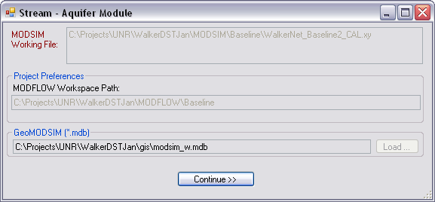

Figure 7. Walker DST Groundwater Module User Interface

The groundwater module executes both mason and smith models using the updated inputs files from the current DST iteration.

### Convergence Checks

The DST checks for convergence, computes state variables, system metrics and stores information about the run in the table *ScenariosInfo* in the *ScenarioInfo* database. Table 11 shows the description of the run summary table fields populated at the end of each iteration.

Table 11. Run Summary Table

|  |  |  |
| --- | --- | --- |
| Field | Units | Description |
| RunDate |  | Date when the run was performed |
| RunIndex |  | This is an scenario-based consecutive counter of iterations. The index should be reset to zero every time that a new set of runs for an scenario are performed. |
| Scenario |  | Name of the scenario that the run belong to |
| RunType |  | This is CAL for MODSIM calibration mode networks and SIM for simulation model networks. |
| MaxOfdiff | [AF/month] | This is the maximum absolute net accretion and depletion difference for any time step over the simulation period in any stream/ditch link between the current and previous MODSIM networks.  This value is used as the convergence criteria since it implies that all the MODFLOW computed accretions/depletions for the MODSIM links between two consecutive runs have changed less than the convergence criteria. |
| MinOfdiff | [AF/month] | This is the minimum absolute net depletion difference for any time step over the simulation period in any stream/ditch link between the current and previous MODSIM networks. |
| AvgOfdiff | [AF/month] | Corresponds to the average of the absolute net depletion difference for any time step over the simulation period in any stream/ditch link between the current and previous MODSIM networks. |
| DepletionConvgAvg | [AF/month] | This variable provides the average shortage computed for the depletions links in the model over the simulated period. |
| DepletionConvgMax | [AF/month] | This variable provides the maximum shortage computed for the depletions links in the model in any time step over the simulated period. |
| MaxMSMF_Flowconvg | [AF/month] | Corresponds to the maximum difference between the MODSIM flow in a link and the MODFLOW flow computed at the downstream end of a link, from the current MODSIM file. The MODFLOW flow is computed based on the previous iteration MODFLOW run, which is consistent with the depletions and accretions simulated in MODSIM in the current iteration. |
| AvgMSMF_FlowConvg | [AF/month] | Corresponds to the average difference between the MODSIM flow in a link and the MODFLOW flow computed at the downstream end of a link. |
| MaxMSM F_FlowConvg_Prev | [AF/month] | Corresponds to the maximum difference between the MODSIM flow in a link in the previous iteration and the MODFLOW flow computed at the downstream end of a link from the current MODSIM file. |
| AvgMSMF_FlowConvg_Prev | [AF/month] | Corresponds to the average difference between the MODSIM flow in a link in the previous iteration and the MODFLOW flow computed at the downstream end of a link from the current MODSIM file. |
| TotShortage | [AF/month] | Corresponds to the total shortage for demands nodes in the MODSIM model, excluding the demands modeling NDOW ponds. |
| MS_NetGaugeGains | [AF] | Total gains computed for the calibration structures in the MODSIM network. |
| MS_NetGaugeLosses | [AF] | Total losses computed for the calibration structures in the MODSIM network. |
| MS_NetGaugeFlow | [AF] | Total net gains/losses computed for the calibration structures in the MODSIM network. |
| previousFile |  | Name of the MODSIM file used for the previous iteration values |
| currentFile |  | Name of the current iteration MODSIM file |
| User |  | User MS-windows log-in corresponding to the user performing the simulation |
| IWRAvg |  | True/False indicating if the average irrigation water requirement methodology was used for this run |
| SmithRCHFiIe |  | Relative path of the recharge smith MODFLOW model file |
| MasonRCHFiIe |  | Relative path of the recharge mason MODFLOW model file |

## Run the Baseline and Application 80700

The DST provided is intended to assist the user with the DST modules iterative process to repeat the Baseline and Application 80700 DST simulations. It is recommended to use the predefined settings and follow the instructions in this section of the user guide to ensure that the models properly converge and a valid solution is achieved. The Baseline and Application (80700) converged runs are provided in the *WalkerFiles* workspace so that the user can observe and analyze the solution and compare results to the repeat runs.

### Setting the Workspace

After installing the Walker DST, the program can be accessed from the start menu shortcut under UNR*→*Walker DST, or in *C:\Program Files(x86)\UNR\WalkerDST* by double clicking on the Walker DST executable to open the program.

The first time the DST is executed a browse window will prompt the user to select the Walker DST workspace. Use the *Browse* window to navigate to the main folder of the DST workspace, called *WakerFiles*, at the location where the workspace was saved in section 5.

Resetting the preferences should not be necessary to complete the model runs. However, should the need arise, the preferences can be reset from the DST Controller. Use the menu *File→Preferences* to access the Preferences user interface (Figure 3). Use the *Browse* button to navigate to the main folder of the DST workspace. Select OK. This will reset all of the preferences for the DST controller.

### Performing the Baseline Run

To start a new Baseline run, a new scenario has to be defined.

* On the DST controller interface select the button *New Scenario* (Figure 1 – Area 1). Define the new scenario name as “Baselinev2” and specify that the new scenario will be based on the “Baseline” scenario.

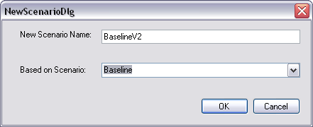

* The run needs to be initialized without any MODFLOW stream-aquifer interaction or Water Balance runoff. To do this click on the *Reset Index* button in Figure 1 – Area 7.
* Next click on the *Settings* tab in the convergence area (Figure 1 – Area 4) and make sure the iterative mode radio button is selected and the tolerance is set to 0.2 [AF/Month] (see Boyle et al. 2013 for an explanation of the tolerance).
* Next click the *Execute* button (Figure 1 – Area 7) to begin the “Baselinev2” DST modules iterative process.
* The Water Right Scenarios interface will appear and spatial processing of the modeling grid will begin.
* Once the spatial processing is complete, examine the purchase summary data table at the top to ensure that there are not purchased water rights in the baseline and click *Continue*.

|  |  |  |  |  |  |
| --- | --- | --- | --- | --- | --- |
| Owner | GISPurchased_Acres | WRPurchased_Acres | TotalArea_Acres | PurchaseFactor | WRAdjFactor |
|  |  |  |  |  |  |

* The Surface Water Modeling user interface will prompt the user for additional input.
  + Browse for the MODSIM base network file that is provided in the Walker Files workspace in the MODSIM baseline folder with the name WalkerNet.xy
  + Select the “Calibration Mode”
  + Click *Continue*

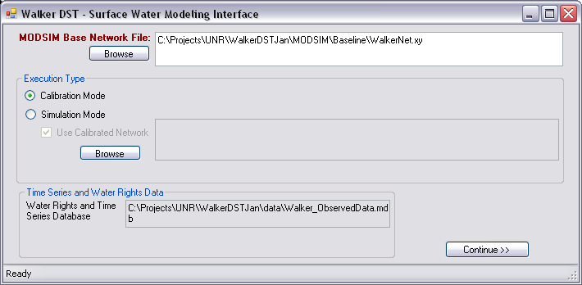

* The HRUBalanceGUI will appear with all the default values required to execute the baseline. Review the default paths and click *Continue*.

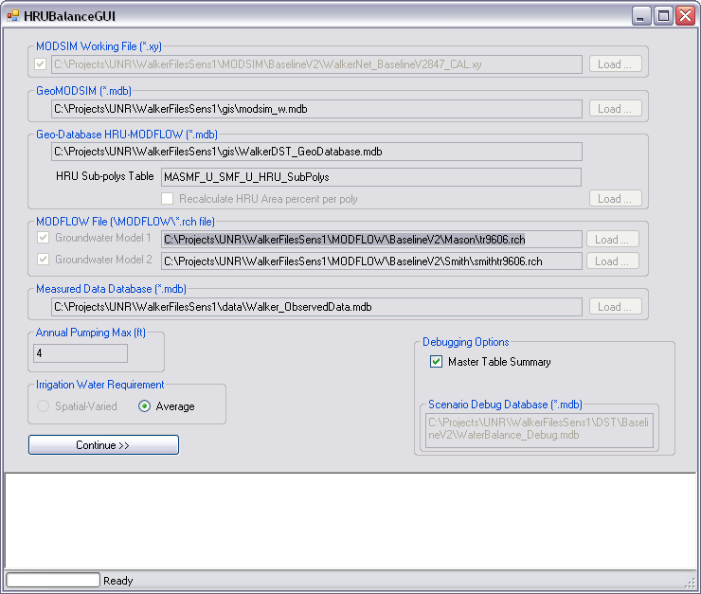

* Next the Stream-Aquifer Module user interface will appear and all that is required is to click *Continue*.

Now the DST will perform a series of successive runs of the three modules with the specified inputs and the most current output of the DST modules until the convergence tolerance is achieved. No other inputs from the user are required during the convergence process. The DST user interface displays a log of the progress in Area 2 of Figure 1. After each iteration, it updates the convergence table on the *Statistics* tab (Area 4 in Figure 1).

Convergence could take up to 24 hours depending on the system hardware and settings. When convergence is achieved a dialogue will pop up indicating that the simulation finished. After completion of the “Baselinev2” run, close the DST controller using the standard Windows Close (X) button.

Note: On the first run a security warning may be triggered because the MODFLOW executables do not have a digital security signature. If this does occur, it will happen in the first 1-hour or so after starting the DST run. Please indicate to your system that it is safe to run this file. If possible, also indicate that the system should not prompt the user about this warning in the future.

### Performing the Application 80700 Run

Return to the start menu and start a new instance of the DST. To begin a new Application80700 run, a new version of the scenario has to be defined.

* On the DST controller interface select the New Scenario button. Define the new scenario name as “App80700v2” and specify that the new scenario will be based on the “App80700” scenario.

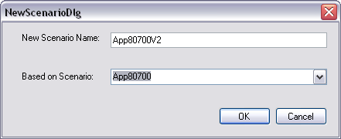

* The run also needs to be initialized without any MODFLOW stream-aquifer interaction or Water Balance runoff. To initialize the run with no information from the other modules click on the *Reset Index* button.
* Next click on the settings tab in the convergence area and make sure that the iterative mode radio button and specify a tolerance of 0.2 [AF/Month] (see Boyle et al. 2013 for an explanation of the tolerance).
* Next click the *Execute* button to begin the “App80700v2” DST modules iteration process.
* Next the Water Right Scenarios interface will appear and spatial processing of the modeling grid will begin.
* Once the spatial processing is complete, examine the purchase summary data table at the top to ensure that the application 80700 purchased water rights are displayed in the summary table and click *Continue*.

|  |  |  |  |  |  |
| --- | --- | --- | --- | --- | --- |
| Owner | GISPurchased_Acres | WRPurchased_Acres | TotalArea_Acres | PurchaseFactor | WRAdjFactor |
| West_Hyland | 640.6251165 | 646.16 | 3691.799892 | 0.173526501 | 0.177618272 |

* The Surface Water Modeling user interface will prompt the user for additional input.
  + Browse for the MODSIM base network file that is provided in the *WalkerFiles* workspace in the MODSIM Baseline folder with the name WalkerNet.xy
  + Select the “Simulation Mode”
  + Check the *Use Calibration Network* option
  + Browse for the last calibration network on the “BaselineV2” MODSIM folder. Note that the last file is the converged baseline file generated in the previous section.
  + Click *Continue*

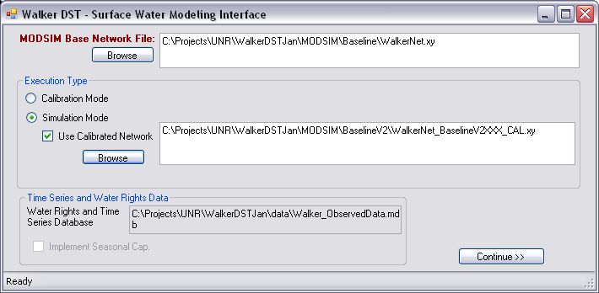

* The HRUBalance user interface will appear with all the default values required to run the scenario Water Balance the scenario application. Click on the *Continue* button.
* The Stream-Aquifer Module will appear with the required settings. Click the *Continue* button.

Now the DST will perform a series of successive runs of the three DST modules with the specified inputs and the most current output of the DST modules until the convergence tolerance is achieved. No other inputs from the user are required during the convergence process. The DST user interface displays a log of the progress in Area 2 of Figure 1 and, after each iteration, it updates the convergence table on the Statistics tab (Area 4 in Figure 1). When converged the controller will display a simulation-finished dialogue. Click OK and close the controller using the standard Windows Close (X) button.

At this point, the user has repeated both of the runs presented in in the report *Walker River Decision Support Tool (version 2.0): Application and Analysis of NSE Application 80700 (Boyle et al. 2013)*.

## Viewing and Comparing the Results

### MODSIM

MODSIM results for each scenario are located in WalkerFiles\MODSIM\ folder of the workspace. In each scenario folder, the file with the largest Run ID will correspond to the converged run for that scenario. River and drain flows for all links in the network can be plotted using the MODSIM GUI to visualize the network flows. Comparison of flows between networks (i.e. the baseline and application scenario) can be visualized using the MODSIM scenario analysis functionality. MS Access can also be used to examine the MODSIM output and build queries. Please see the MODSIM user manual and MS-Access help for more information.

### HRU Water Balance

The HRU Water Balance results for each scenario can be found in the WalkerFiles\DST\ folder of the workspace. For example, to locate the “Baselinev2” scenario results, browse to “Baselinev2” folder and locate the file WaterBalance_Debug.mdb. This file contains the Water balance results for each run in the “Baselinev2” scenario. The MS-Access tables show the HRU grouped water balance results in depth (meters/month) and the total pumping per well (cubic meters per month) for each run.

A set of queries are generated for the user in this database to summarize the volumetric Water Balance calculations by Sub-Polys and HRUs in metric (cubic meters and meters) and English units (Acre-Feet (AF) and Feet (ft.)) for each Run ID. These queries by default are created with relative paths. To execute the database queries, the *WalkerFiles* workspace should be assigned in the MS-Access options as the default database folder (Figure 8).



Figure 8. MS-Access Default Database Folder Options

After the App80700 iterative process, an equivalent file should exists in WalkerFiles\DST\App80700v2 folder.

The sub-poly queries need to be filtered before running because they are too large to display unfiltered. The most useful queries of the HRU Water Balance are summarized by HRU. These are queries having a name like the one below:

“WalkerNet_”, “ScenarioName” . “RunID”, “CAL or SIM”, “WG_Summary_HRU_”, “AF or Ft”

Example 1:

* ScenarioName = Baselinev2
* Run ID = 851
* Run Execution Type = CAL
* Units = AF
* Query Name = Baselinev2851_CAL_WG_Summary_HRU_AF

Example 2:

* ScenarioName = App80700
* Run ID = 921
* Run Execution Type = SIM
* Units = Ft
* Query Name = App80700921_SIM_WG_Summary_HRU_Ft

Within each of the queries named “WG_Summary_HRU_”, “AF or Ft”, the information in Table 12 is available. Please see the HRU Water Balance section in Boyle et al. 2013 for more information on the meaning of these variables.

Table 12. Listing of available information in WG_Summary_HRU queries

|  |  |
| --- | --- |
| Column Header | Description |
| TSDate | Time Step |
| DitchName | Ditch Assignment |
| AcreageIrrigated | Total Acres Irrigated |
| PumpingAcreageIrrigated | Acres Irrigated with Pumping |
| DCL_Factor | Ditch Conveyance Loss Factor |
| Efarm | Farm Efficiency |
| Div1 | Diversion |
| DitchLeakage | Ditch Leakage |
| Div2 | Div1-DitchLeakage |
| CropDemand | NIWR |
| FIWR | NIWRE |
| Preq | Permitted Pumping Required |
| Pmax | Permitted Annual pumping Maximum |
| Pact | Permitted Actual Pumping |
| App | Water Application |
| NCU | Non-Consumptive Use |
| CropSupply | Consumptive Use |
| OverDelivery | Surface Water Excess |
| TotalNCU | Total Non-Consumptive Use |
| Rfactor | Runoff Factor |
| Runoff | Runoff |
| Recharge | Recharge |
| WBalCheck | Check on Water Balance |
| CropShortage | Crop Deficit |

### MODFLOW

Standard MODFLOW results are generated in flat text files. The results can be viewed in text editor software; however, additional software (as referenced in the Installation and Setup Section) will be required for further analysis.

## References

Boyle, D. P. (2010). *Project F:F.1 - Development of a Decision Support Tool in Support of Water Right Aquisitions in the Walker River Basin, In Restoration of a Desert Lake in an Agriculturally Dominated Watershed: The Walker Lake Basin. M.W. Collopy and J.M. Thomas (eds.).*

Boyle, D. P. (2013). *Walker River Decision Support Tool (version 2.0): Application and Analysis of NSE Application 80700.*

Harbaugh, A. E. (2000). *MODFLOW-2000, the U.S. Geological Survey Modular Ground-water Model – User Guide to Modularization Concepts and the Ground-water Flow Process.* U.S. Geological Survey.

Labadie, J. W. (2006). MODSIM: River Basin Management Decision Support System. In V. P. Singh, & D. K. Frevert, *Watershed Models* (p. Chapter 23 ). Boca Raton, FL: CRC/Taylor & Francis.

Minor, T. A. (2010). *Project I: Development of a Water Distribution and Water Rights GIS Database for Integration with a Water Flow Model in the Walker Basin, In Restoration of a Desert Lake in an Agriculturally Dominated Watershed: The Walker Lake Basin. M.W. Collopy and J.M. Thomas (eds.).*

1. Note that the MODSIM Base Network is modified during the pre-process steps but the original is file preserved. This guarantees that any subsequent MODSIM iteration will start from the same point.